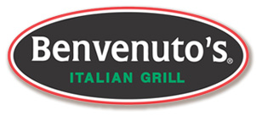
DINE OUT FOR
Benvenuto’s Italian Grill invites you to dine out and support!
Monday, November 21st 2016
11am – 10pm
20% of all participant sales from 11:00 a.m. – 10:00 p.m. will be donated to Ad 2 Madison.
To participate, bring in your flyer and Dine or Mention that you are here to support Ad 2 Madison.

Benvenuto’s Italian Grill is a locally owned and operated business and we believe in neighbors helping neighbors!
www.benvenutos.com

